# Part 1 Gamma Correction

1. Gamma Correction

Function:

function [NewImg] = GammaCorrection(img,gamma)

[Rows, Cols] = size(img);% get the size of img

DImg = double(img);% convert img to double

%update the value pixel by pixel

for i = 1:Rows

for j = 1:Cols

DImg(i,j) = 255*(DImg(i,j)/255)^gamma;

end

end

NewImg = uint8(DImg); % restore the default img format uint8

% with this command, the floating point value would be

% rounded and the range would be set to [0,255]

end

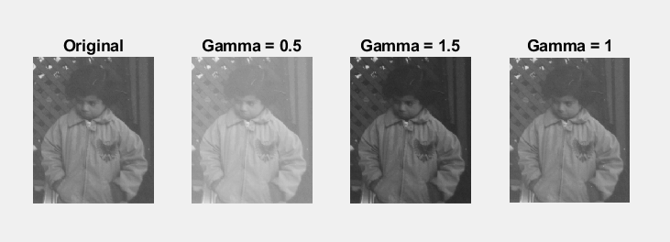

1. Enhance Moon  
   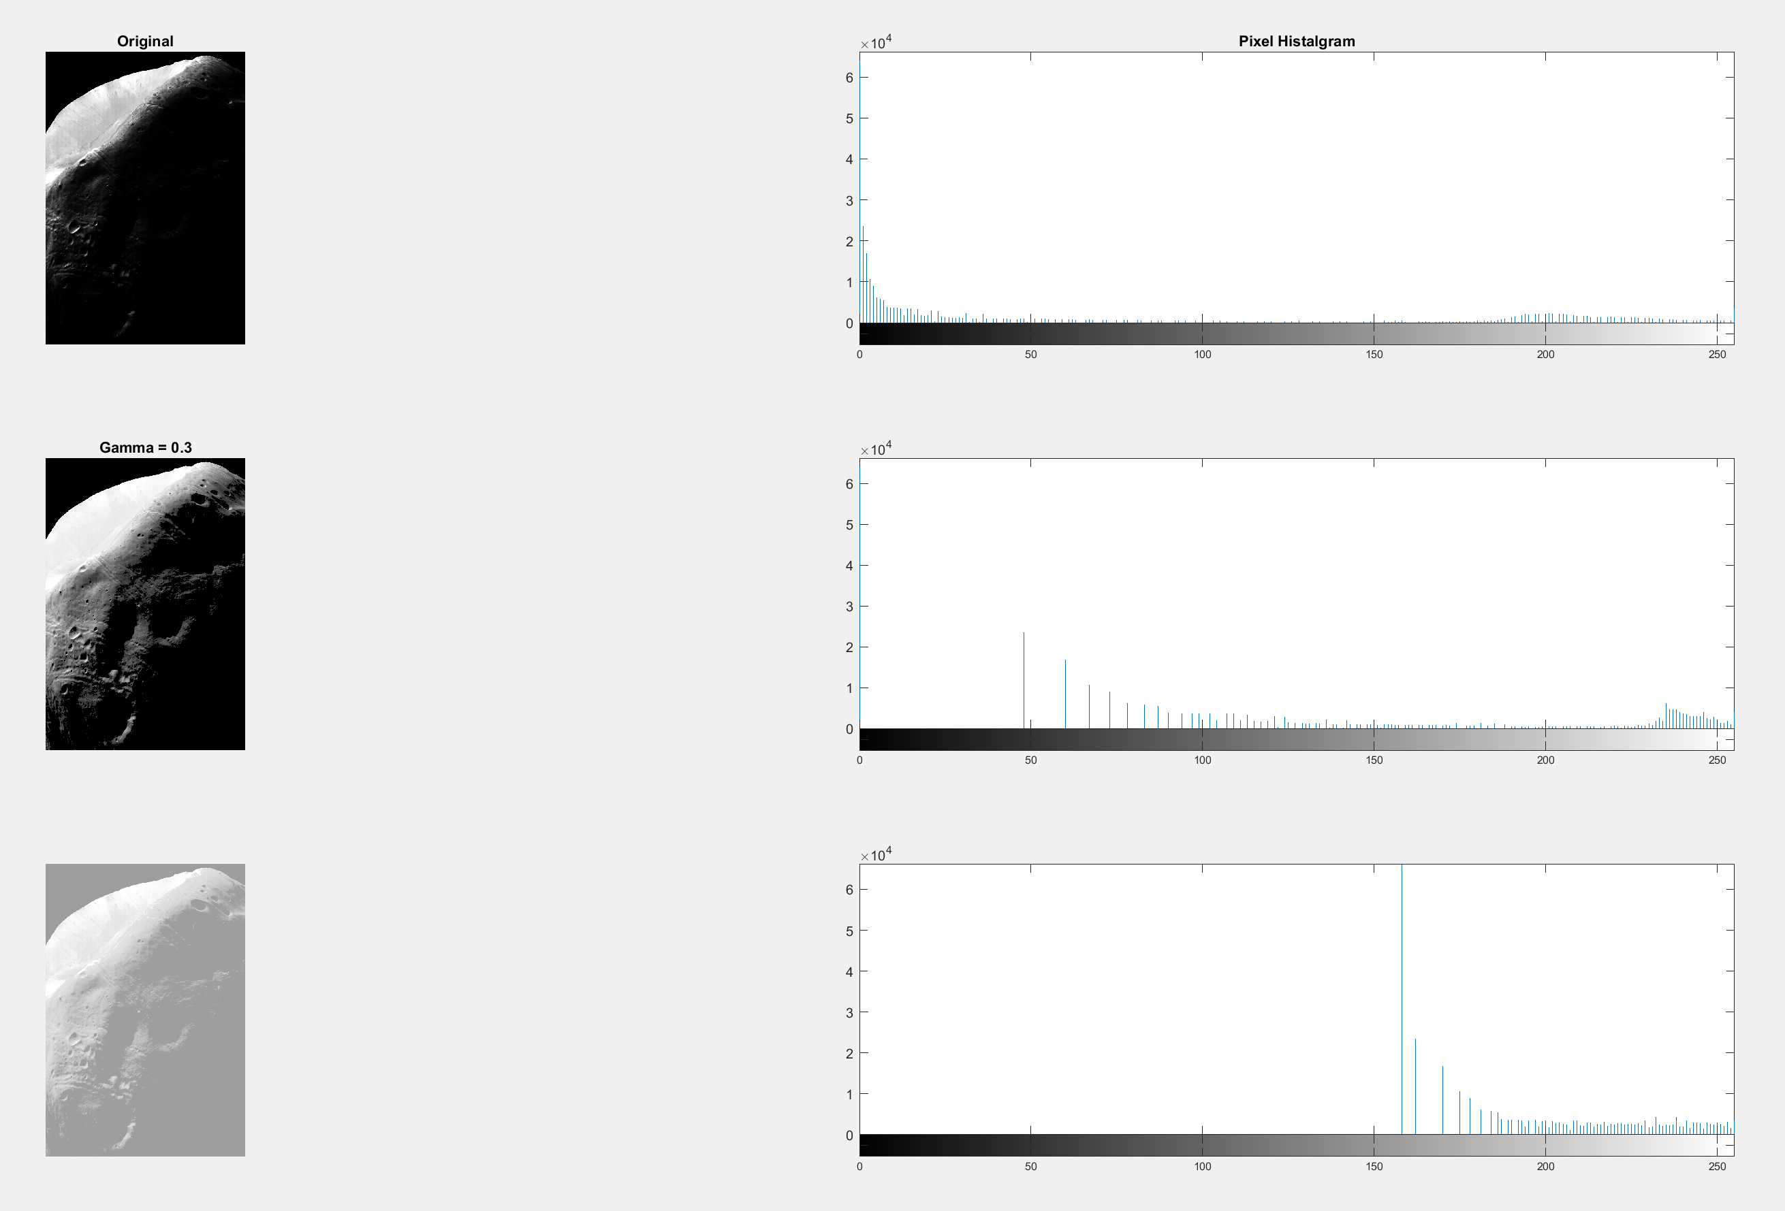

# Part 2 Sharpen

1. Sharpen Moon

Function:

function [NewImg] = Sharpen(img,alpha)

DImg = double(img);% convert img to double

%update the value pixel by pixel

Laplacian = [0 -0.25 0;

-0.25 1 -0.25;

0 -0.25 0]

G = filter2(Laplacian,DImg);

NewImg = uint8(DImg+alpha*G); % restore the default img format uint8

% with this command, the floating point value would be

% rounded and the range would be set to [0,255]

end

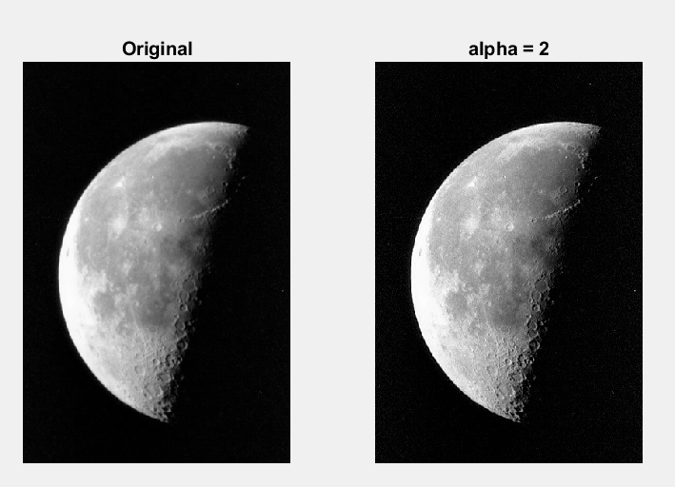

1. Out of Focus

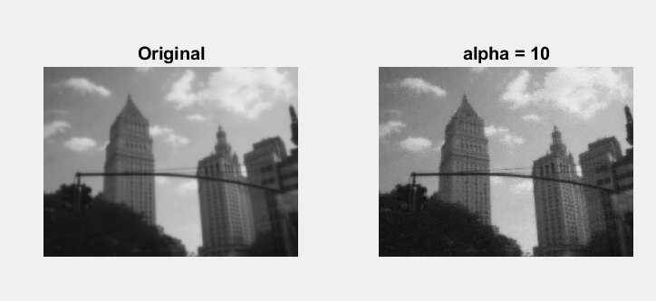

# Part 3 Filter

1. 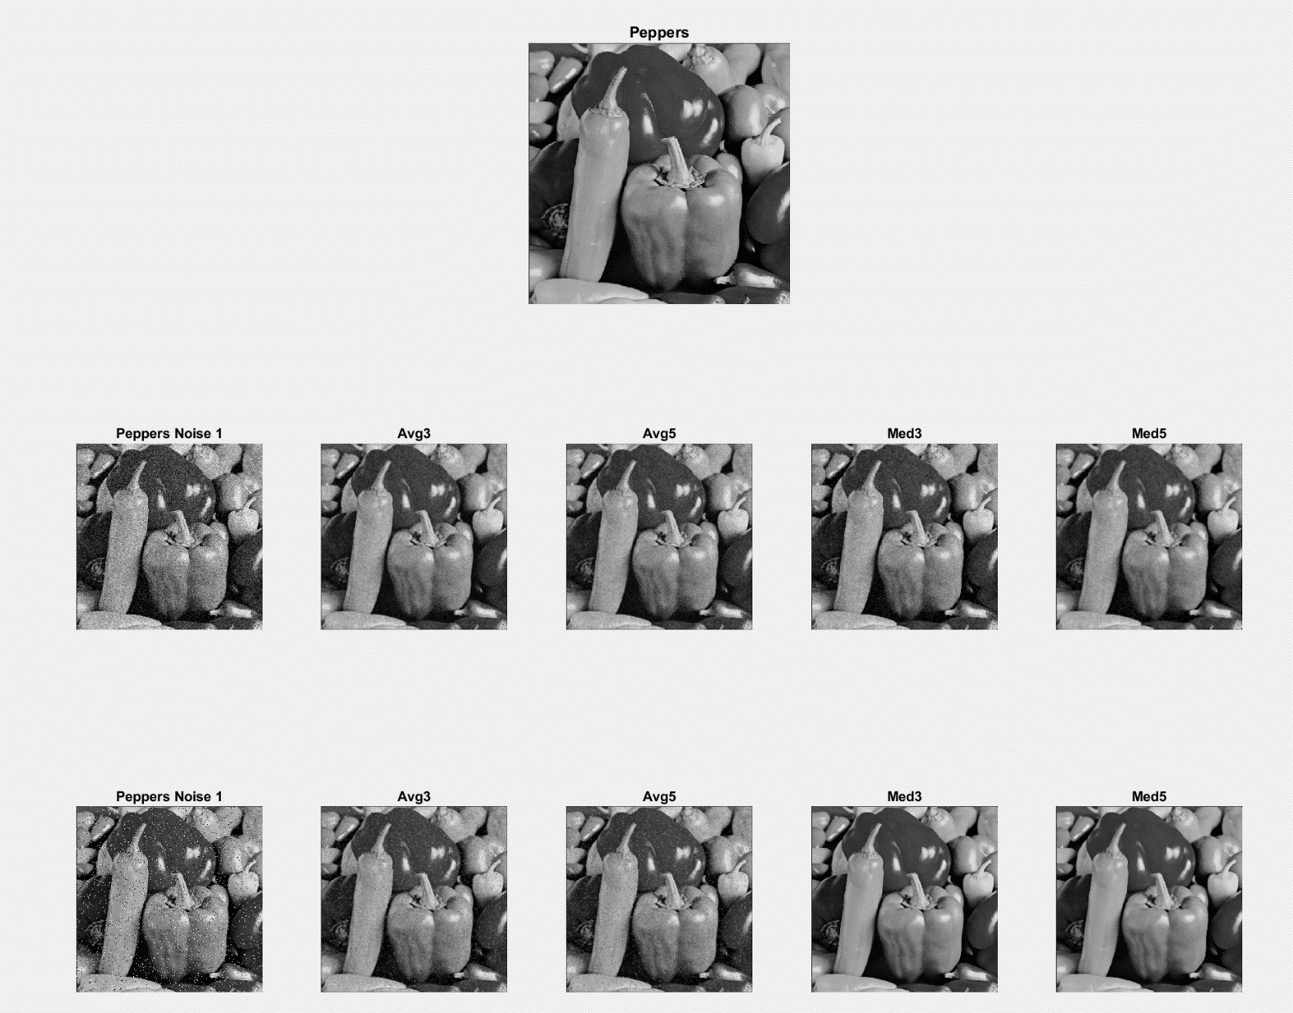Comparation between Average Filter and Median Filter
2. Edge Detection with Noise  
   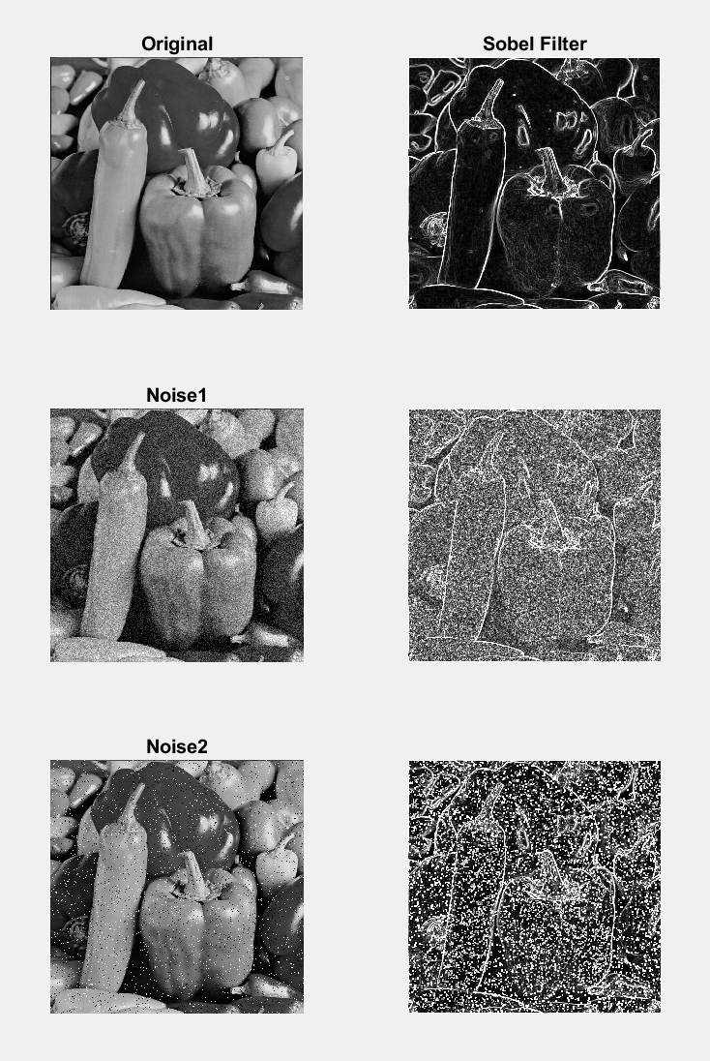

# Appendix

## Part 1:

### Gamma Correction

close all; clear all; clc;

format compact;

%% Part 1 Gamma Correction

img = imread('pout.tif');

type GammaCorrection

figure(1);

subplot(1,4,1);

imshow(img);

title("Original");

% Img with different Gamma Value

subplot(1,4,2);

gamma0 = 0.5;

NewImg0 = GammaCorrection(img,gamma0);

imshow(NewImg0)

title(['Gamma = ',num2str(gamma0)]);

subplot(1,4,3);

gamma1 = 1.5;

NewImg1 = GammaCorrection(img,gamma1);

imshow(NewImg1)

title(['Gamma = ',num2str(gamma1)]);

subplot(1,4,4);

gamma2 = 1;

NewImg2 = GammaCorrection(img,gamma2);

imshow(NewImg2)

title(['Gamma = ',num2str(gamma2)]);

### Enhance Moon

moonPhobos = imread('MoonPhobos.tif');

figure(2);

subplot(3,2,1);

imshow(moonPhobos)

title('Original');

subplot(3,2,2);

imhist(moonPhobos);

title('Pixel Histalgram');

subplot(3,2,3);

% Gamma value = 0.3

CorrectionCoefficient = 0.3;

moonPhobosEn = GammaCorrection(moonPhobos,CorrectionCoefficient);

imshow(moonPhobosEn)

title(['Gamma = ',num2str(CorrectionCoefficient)]);

subplot(3,2,4);

imhist(moonPhobosEn);

% histeq method

subplot(3,2,5);

moonPhobosEq = histeq(moonPhobos,256);

imshow(moonPhobosEq)

subplot(3,2,6);

imhist(moonPhobosEq);

## Part 2:

close all; clear all; clc;

format compact;

%% Part 2 Sharpen Moon

figure(1)

moon = imread('moon.tif');

subplot(1,2,1);

imshow(moon);

title("Original");

% Sharpened Img with different alpha Value

subplot(1,2,2);

alpha0 = 2;

NewImg = Sharpen(moon,alpha0);

imshow(NewImg)

title(['alpha = ',num2str(alpha0)]);

%% Sharpen outoffocus

figure(2)

OutOfFocus = imread('outoffocus.tif');

subplot(1,2,1);

imshow(OutOfFocus);

title("Original");

subplot(1,2,2);

alpha1 =10;

FixedImg = Sharpen(OutOfFocus,alpha1);

imshow(FixedImg)

title(['alpha = ',num2str(alpha1)]);

## Part 3:

### Average Filter and Med Filter

figure(1)

peppers = imread('peppers.tif');

subplot(3,5,1:5);

imshow(peppers);

title('Peppers');

subplot(3,5,6);

peppersnoise1 = imread('peppersNoise1.tiff');

imshow(peppersnoise1);

title('Peppers Noise 1');

subplot(3,5,7);

avgMask3= ones(3)/9;

peppers1Avg3= filter2(avgMask3,peppersnoise1);

imshow(uint8(peppers1Avg3))

title('Avg3');

subplot(3,5,8);

avgMask5= ones(5)/25;

peppers1Avg5= filter2(avgMask3,peppersnoise1);

imshow(uint8(peppers1Avg5))

title('Avg5');

subplot(3,5,9);

peppers1Med3= medfilt2(peppersnoise1,[3 3]);

imshow(peppers1Med3)

title('Med3')

subplot(3,5,10);

peppers1Med5= medfilt2(peppersnoise1,[5 5]);

imshow(peppers1Med5)

title('Med5')

subplot(3,5,11);

peppersnoise2 = imread('peppersNoise2.tiff');

imshow(peppersnoise2);

title('Peppers Noise 1');

subplot(3,5,12);

avgMask3= ones(3)/9;

peppers2Avg3= filter2(avgMask3,peppersnoise2);

imshow(uint8(peppers2Avg3))

title('Avg3');

subplot(3,5,13);

avgMask5= ones(5)/25;

peppers2Avg5= filter2(avgMask3,peppersnoise2);

imshow(uint8(peppers2Avg5))

title('Avg5');

subplot(3,5,14);

peppers2Med3= medfilt2(peppersnoise2,[3 3]);

imshow(peppers2Med3)

title('Med3')

subplot(3,5,15);

peppers2Med5= medfilt2(peppersnoise2,[5 5]);

imshow(peppers2Med5)

title('Med5')

### Sobel Filter

SobelX = [ -1 0 1

-2 0 2

-1 0 1 ];

SobelY = SobelX';

figure(2)

peppers = imread('peppers.tif');

subplot(3,2,1)

imshow(peppers)

title('Original');

subplot(3,2,2)

Gx= filter2(SobelX,peppers);

Gy= filter2(SobelY,peppers);

gradMag= (Gx.^2 + Gy.^2).^.5;

imshow(uint8(gradMag))

title('Sobel Filter')

peppersnoise1 = imread('peppersNoise1.tiff');

subplot(3,2,3)

imshow(peppersnoise1)

title('Noise1')

% show the magnitude of the image's gradient

subplot(3,2,4)

% calculate the gradient in each cardinal direction

Gx1= filter2(SobelX,peppersnoise1); % x-direction

Gy1= filter2(SobelY,peppersnoise1); % y-direction

gradMag1= (Gx1.^2 + Gy1.^2).^.5;

imshow(uint8(gradMag1))

subplot(3,2,5)

peppersnoise2 = imread('peppersNoise2.tiff');

imshow(peppersnoise2)

title('Noise2')

subplot(3,2,6)

Gx2= filter2(SobelX,peppersnoise2); % x-direction

Gy2= filter2(SobelY,peppersnoise2); % y-direction

gradMag2= (Gx2.^2 + Gy2.^2).^.5;

imshow(uint8(gradMag2))